yum install wget -y
wget http://dl.fedoraproject.org/pub/epel/6/x86_64/epel-rele
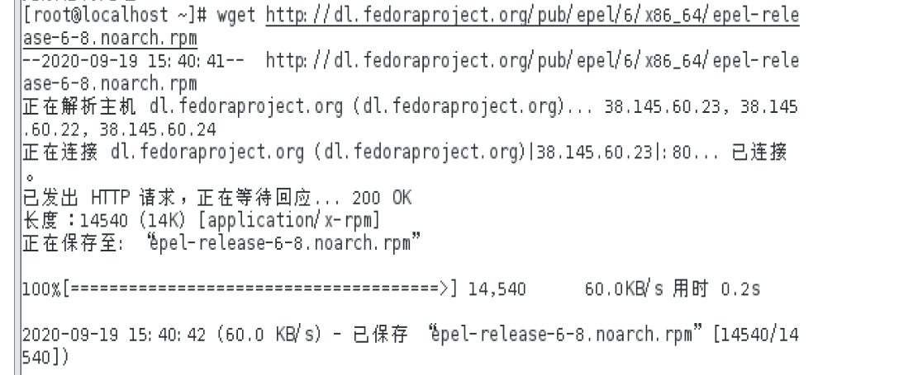
yum install epel-release-6-8.noarch.rpm
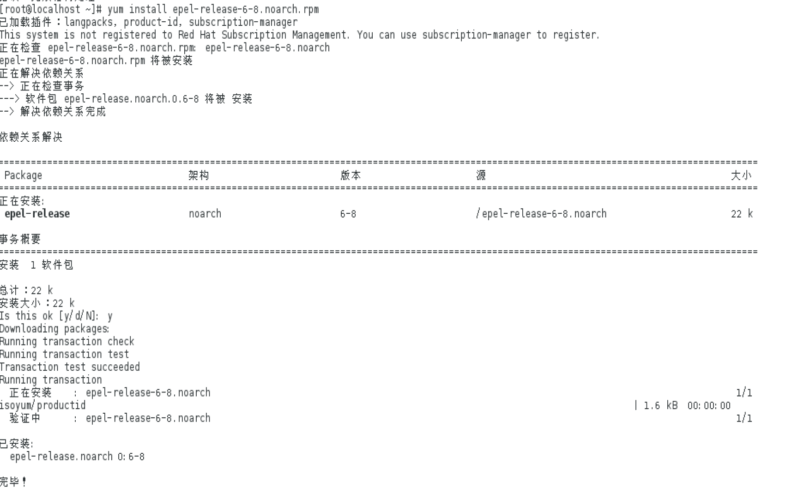
vim /etc/yum.repos.d/epel.repo
注释修改
